Magister voltooi 2013
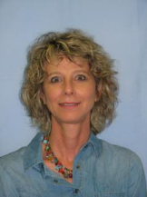 | BASSON M. Die ontwikkeling van geletterdheidsintervensie-programme ter bevordering van woordeskat en leesbegrip by Xhosa-moedertaalsprekers in graad 4-6 Afrikaansklasse. MEd, 2013. 170 pp.  Studieleier: Le Cordeur ML  Medestudieleier: Rutgers L | 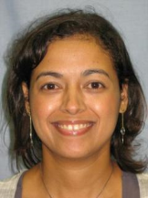 | DOMINGO C. Reflective practice as a mechanism for professional development: a narrative inquiry. MEd, 2013. 157 pp.  Studieleier: Reddy CPS
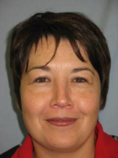 | DUNN M. Promoting social change amongst students in higher education: an evaluation of the Listening, Living and Learning senior student housing programme at Stellenbosch University. MPhil, 2013. 172 pp.  Studieleier: Prof M Fourie-Malherbe | 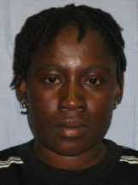 | HAINDONGO NS. Environmental education in Namibia: a case study of the biology teachers. MEd, 2013. 219 pp.  Studieleier: Reddy CPS. Medestudieleier: Botha ML
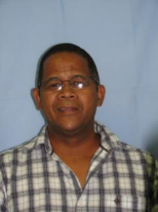 | KLAASEN D. ‘n Poging om my klaskamerpraktyk in beroepsvoorligting by ‘n landelike VOO-skool te verbeter: ‘n aksienavorsings-benadering. MEd, 2013. 147 pp.  Studieleier: Esau O | 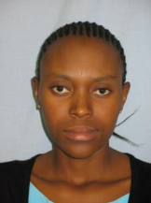 | KOBO MJ. Communicative language teaching: a comparison of the Lesotho form E (English) and South African grade 12 FAL (English) curricula. MEd, 2013. 91 pp. Studieleier: Van der Walt C
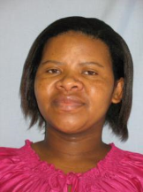 | KOTELA BS. The use of practical activities to address Grade 11 learners’ conceptual difficulties in electricity and magnetism. MEd, 2013. 164 pp.  Studieleier: Mnr N Edwards | 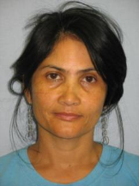 | LANGEVELDT F. Die erkenning van voorafleer as ‘n meganisme ter voorbereiding van ouer volwassene studente se sukses aan ‘n Hoëronderwysinstelling. MPhil, 2013. 99 pp.  Studieleier: Dr BL Frick
 | LOURENS E. Understanding the experiences of educationally disadvantaged students at Stellenbosch University. MEd, 2013. 176 pp. (cum laude)  Studieleier: prof M Fourie-Malherbe  Medestudieleier: Dr M Ndlovu | 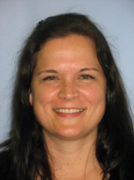 | SWART C. An analysis of the tourism curriculum at Boland College: What the tourism industry in Stellenbosch requires from entry level college employees. MPhil, 2013. 178 pp.  Studieleier: Bitzer EM.
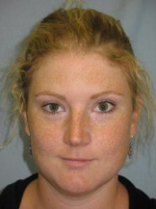 | VANDENBERGH SJE. Towards explaining doctoral success at Stellenbosch University. MPhil, 2013. 168 pp. Studieleier: Bitzer EM. Medestudieleier: Frick BL.

